Morayfield State School

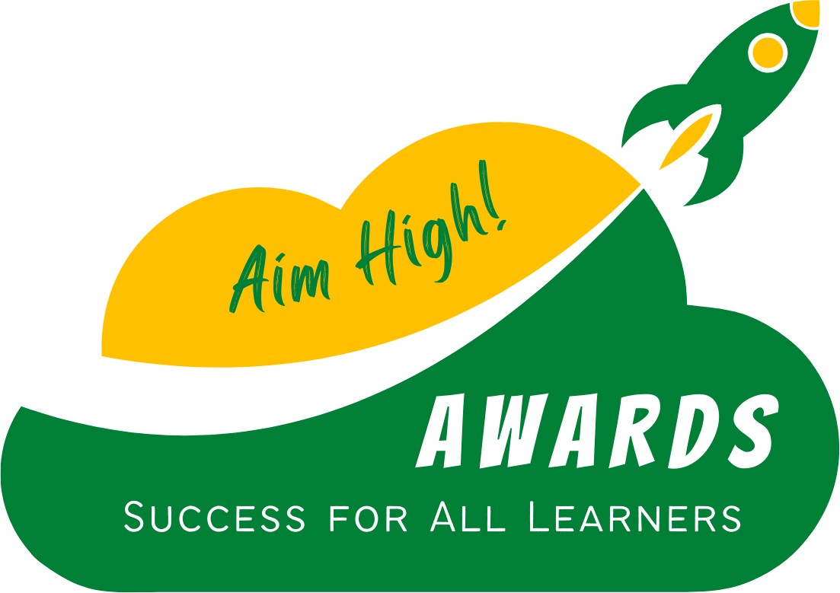

**End of Year Academic Awards & Selection Criteria**

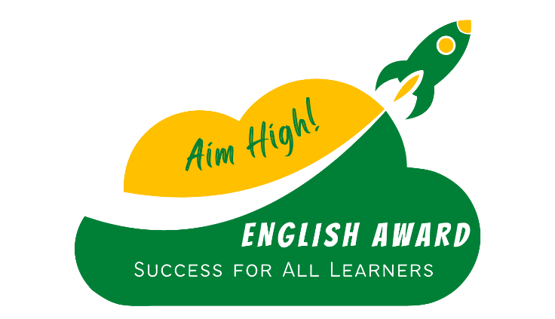

# ENGLISH AWARD

This award has been provided to the student who has achieved the highest Academic Result for English within each class for the entire academic year.

#### Award Criteria:

* English achievement for the 2024 Academic Year is through review of Language, Literature and Literacy demonstrated knowledge and skill
* Students who achieve the highest academic result for English, display skills of listening, reading, viewing, speaking, writing, creating and reflecting
* Student with the highest A-C result of the class receives

the English Award

* In the circumstance of a matched result, the Effort Achievement across the year is utilised to identify the

highest achiever.

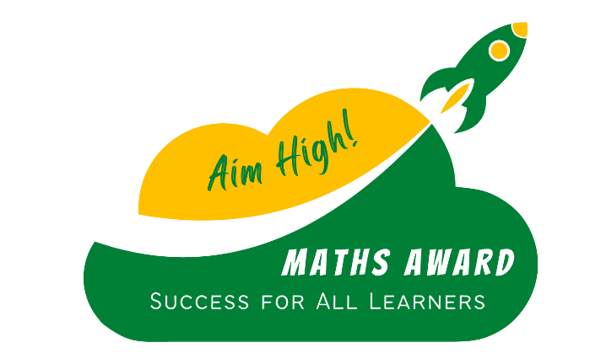

# MATHS AWARD

This award has been provided to the student who has achieved the highest Academic Result for Mathematics within each class for the entire academic year.

#### Award Criteria:

* Maths achievement for the 2024 Academic Year is through review of Number & Algebra, Measurement & Geometry and Statistics & Probability demonstrated knowledge and skills
* Students who achieve the highest academic result for Maths, displaying skills of understanding, fluency, problem solving and reasoning
* Student with the highest A-C result of the class receives

the Maths Award

* In the circumstance of a matched result, the Effort achievement across the year is utilised to identify the

highest achiever.



# SCIENCE AWARD

This award has been provided to the student who has achieved the highest Academic Result for Science within each class for the entire academic year.

#### Award Criteria:

* Science achievement for the 2024 Academic Year is through review of strands of Science Knowledge, Science as a Human Endeavour and Science Skills demonstrated knowledge and skills
* Students who achieve the highest academic result for Science, displaying skills of understanding, fluency, problem solving and reasoning
* Student with the highest A-C result of the class receives

the Science Award

* In the circumstance of a matched result, the Effort achievement across the year is utilised to identify the

highest achiever.

# 

# AIM HIGH AWARD

This award has been provided to the student who has achieved the highest Effort & Behaviour achievement within the class for the entire academic year.

#### Award Criteria:

* Effort:

*Consistently:*

-contributes eagerly and constructively to class discussions

-manages time effectively

-works independently and in groups

-engages in new/difficult tasks and took responsibility in own learning

-shows enthusiasm and commitment to all learning

-readily accepts feedback and applies to own learning

* + - * Behaviour:

*Consistently:*

-0 behaviour interventions required

-stays focussed and on-task in the classroom

-interacted appropriately in the playground using High-5 strategy

-displays Respectful, Responsible & Safe actions at MSS

-works well with all staff and visiting teachers

-exhibits respect for school and classroom equipment

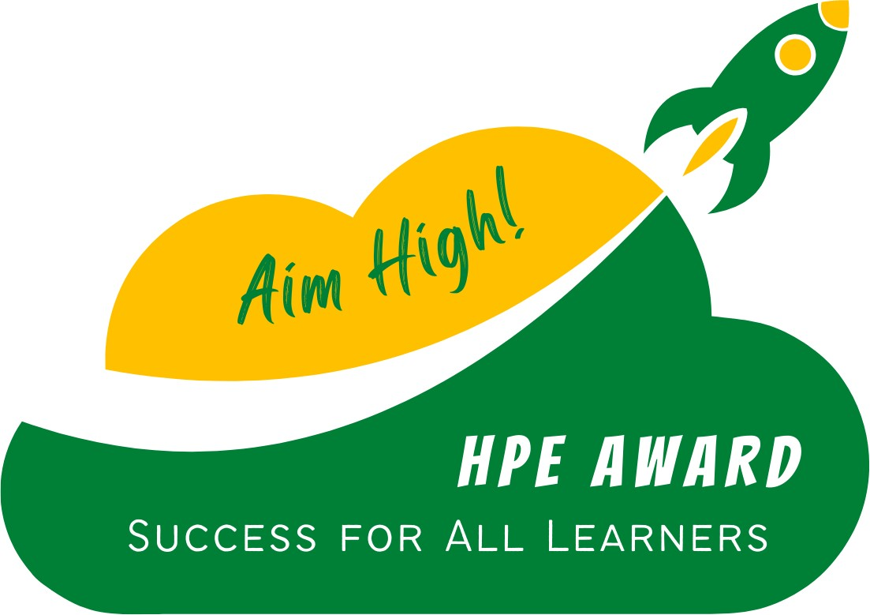

# HPE

This award has been provided to the student who has achieved the highest Academic Result for HPE within the year level for the entire academic year.

#### Award Criteria:

* HPE achievement for the 2024 Academic Year is through review of Personal Health and Movement & Physical Activity knowledge and skills demonstrated
* Students who achieve the highest academic result for HPE, display skills of personal health awareness and movement abilities
* Student with the highest A-C result of the class receives the HPE Award
* In the circumstance of a matched result, the Effort Achievement across the year is utilised to identify the highest achiever.



# THE ARTS

This award has been provided to the student who has achieved the highest Academic Result for The Arts within the year level for the entire academic year.

#### Award Criteria:

* The Arts achievement for the 2024 Academic Year is through review of Visual Arts & Media Arts knowledge and skills
* Students who achieve the highest academic result for The Arts, display skills of body awareness, technical skills and creativity
* Student with the highest A-C result of the class receives the Arts Award
* In the circumstance of a matched result, the Effort Achievement across the year is utilised to identify the highest achiever.

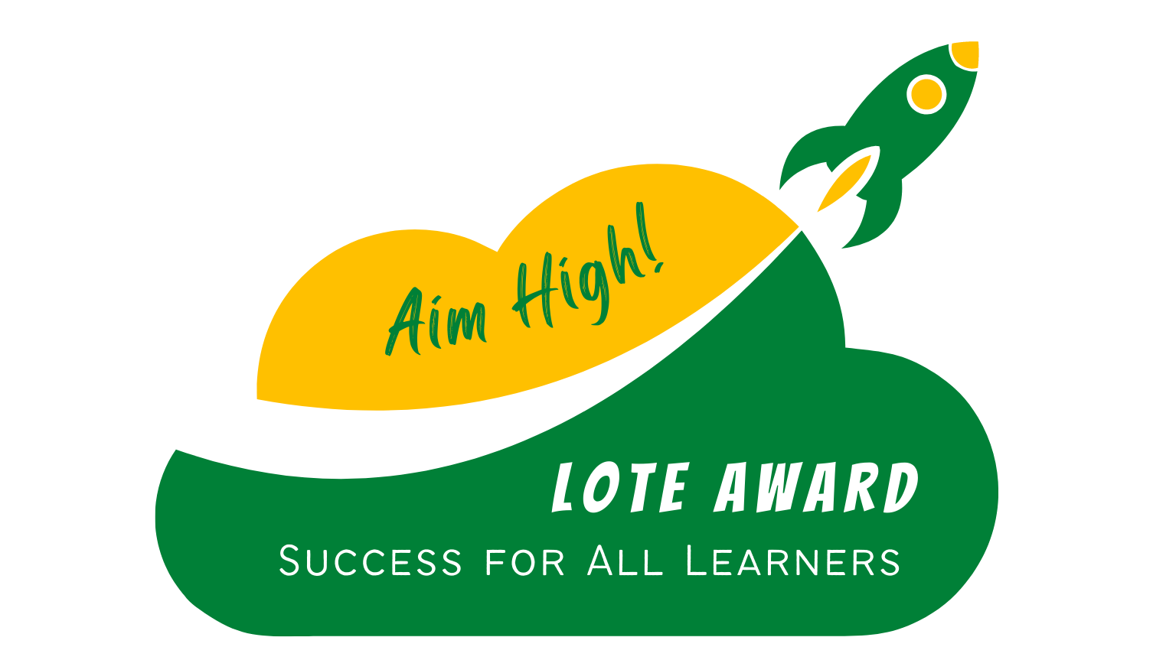

### LOTE

This award has been provided to the student who has achieved the highest Academic Result for LOTE within the Year 5 and 6 year level for the entire academic year.

#### Award Criteria:

* LOTE achievement for the 2024 Academic Year is through review of Communicating and Understanding of Language knowledge and skills
* Students who achieve the highest academic result for LOTE, display skills of cultural awareness, language and written abilities of the Japanese culture
* Student with the highest A-C result of the class receives the LOTE Award
* In the circumstance of a matched result, the Effort Achievement across the year is utilised to identify the

highest achiever.

*** Each successful recipient will receive a medal and a certificate

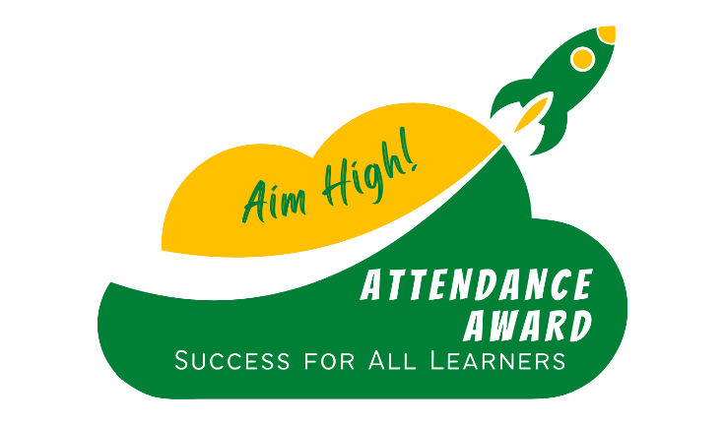

# ATTENDANCE AWARD

This award has been provided to a student who has achieved attendance of 92% and above across the 2024 School Calendar year.

#### Award Criteria:

* 92% is achieved through 2024
* Students absence data is taken from the student dashboard on OneSchool
* Percentages are rounded up if applicable



# PRINCIPAL’S AWARD

This award is presented to a learner that has been a positive ambassador for Morayfield State School throughout the year.

#### Award Criteria:

* This learner upholds the 3 school values of being Respectful, Responsible & Safe
* The learner has actively engaged and participated in school events, daily school life and demonstrated resilience and perseverance
* Each year level has one recipient

*** Each successful recipient will receive a trophy and a certificate

*** Year 6 Recipient will receive a trophy, PCYC bursary and a certificate

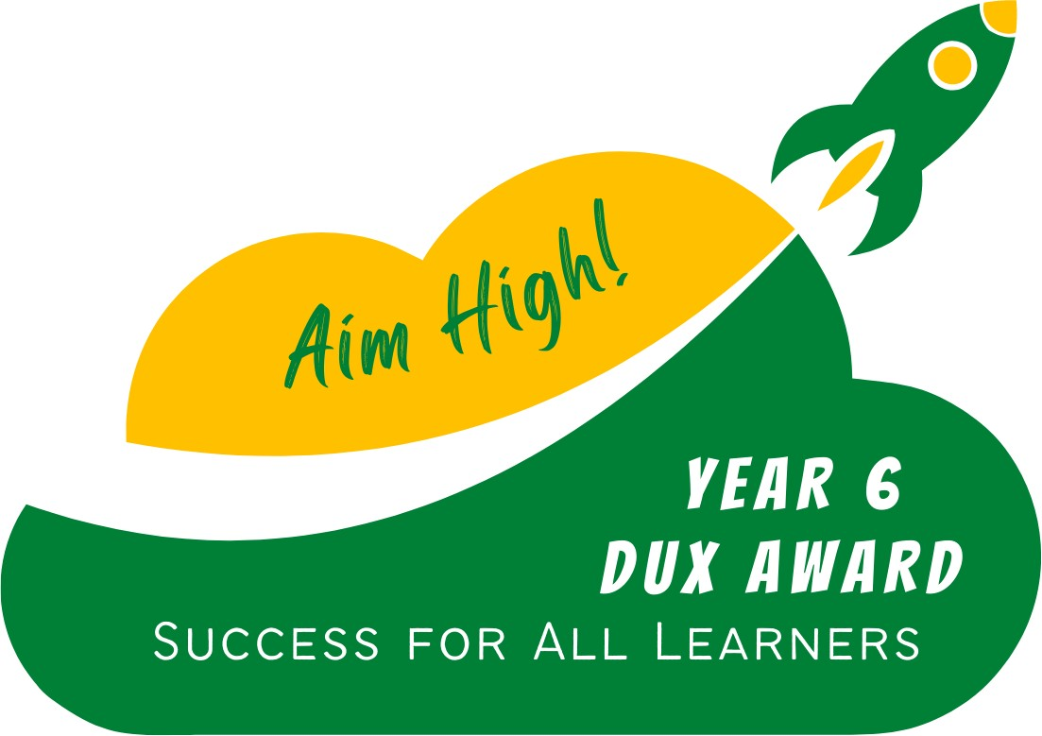

## Year 6 Award DUX

This award is presented to one year 6 learner who has received the highest academic across learning areas within the 2024 school year, their final year of schooling.

#### Award Criteria:

* This learner received the highest English and Mathematics achievement within the year 6 cohort
* All other learning areas, this student based on judgement across the eight areas, has achieved the highest average

*** Each successful recipient will receive a PCYC Bursary, trophy and a certificate



## Year 6 Award CITIZENSHIP

This award is presented to the learner who exemplifies the Morayfield Way, ensuring that they are always leading their actions with Respectful, Responsible and Safe behaviours.

They actively serve the Morayfield State School community and are positive in their interactions with all students, staff and parents.

#### Award Criteria:

* Displays leadership within the cohort
* Supports staff with a positive and can-do attitude
* Offers their time to set up for whole school events
* Active role model to other students
* Wears uniform with pride
* Positive behaviour interactions with all members of the community

*** Each successful recipient will receive a PCYC Bursary, trophy and a certificate



## Year 6 Award SPORTS AWARD

This award is presented to the learner who has excelled in all areas of sport, both internal and external to Morayfield State School.

#### Award Criteria:

* This learner has willingly participated in all PE lessons
* This learner has participated in gala days across the year
* This learner displayed sportsmanship on the field and has a positive impact on team mates
* Attendance at the sports day event
* Active role model for the sports house at Sports Day
* District or Regional level sport participation may have

occurred

*** Each successful recipient will receive a PCYC Bursary, trophy and a certificate

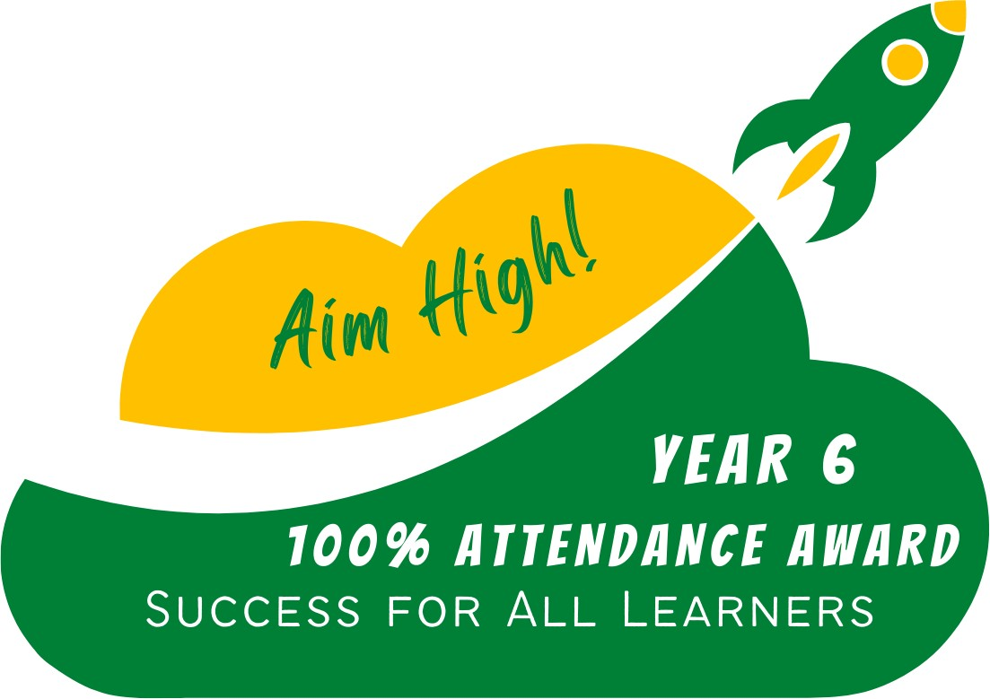

### Year 6 Award

**100% PRIMARY SCHOOL ATTENDANCE**

This award is presented to a learner who has achieved 100% attendance across their primary schooling years from Prep to Grade 6.

#### Award Criteria:

* 100% attendance in Prep
* 100% attendance in Grade 1
* 100% attendance in Grade 2
* 100% attendance in Grade 3
* 100% attendance in Grade 4
* 100% attendance in Grade 5
* 100% attendance in Grade 6
* During periods of school closure, exemption to the attendance rate is provisioned.

*** Each successful recipient will receive a trophy and a certificate